PTSPowerHub mobile workflow for Engineer

Contents
Mobile workflow: 2
Single engineer flow –one visit: 2
Single engineer flow –two visits: 2
Login page : 3
After login : 3
Punch In /Punch Out: 4
Tripstart and Tripfinish: 5
Workstart and Workfinish: 6
Call finish: 9
Attachment detail: 10

Mobile workflow:

Single engineer flow –one visit:
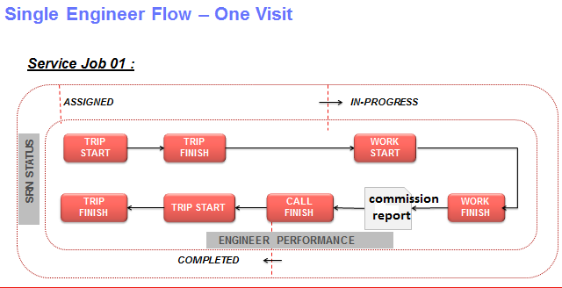
According to call type form will change commission/job card/ LT form

Single engineer flow –two visits:

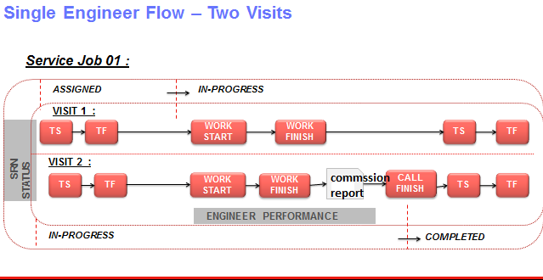
According to call type form will change commission/job card/ LT form

Loginpage :
Open the PTS Powerhub App and login:
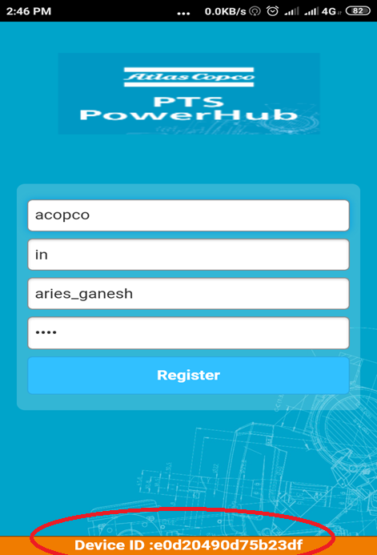

After login :
Open the PTS Powerhub App and login:
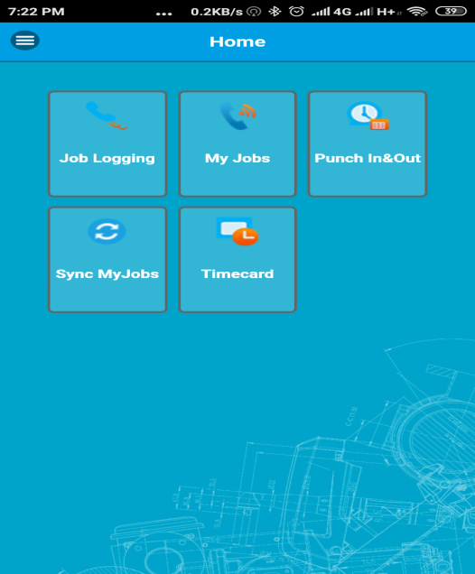

Punch In /Punch Out:
On home screen, Touch on Punch Infor your attendance at every morning/Out Button for your attendance at every evening:
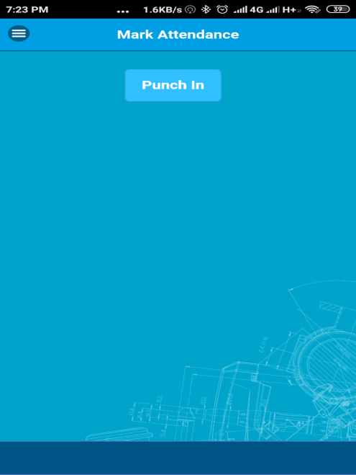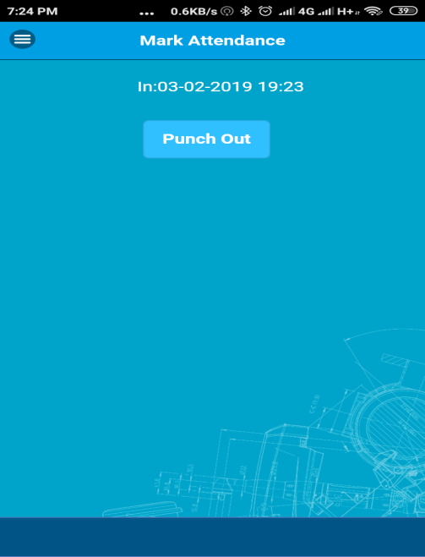

After Punch In, touch on Sync My Jobs button:
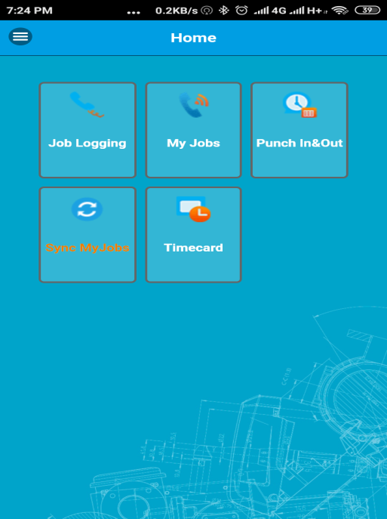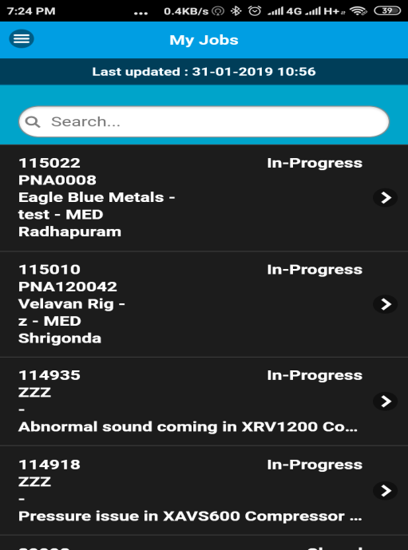

Tripstart andTripfinish:
Touch on that call number and choose T-start for starting your Trip:
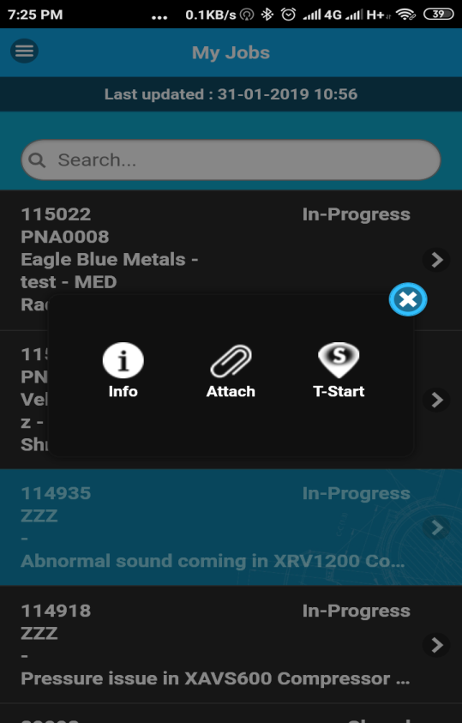

Once you reached at site, press on T-finish:
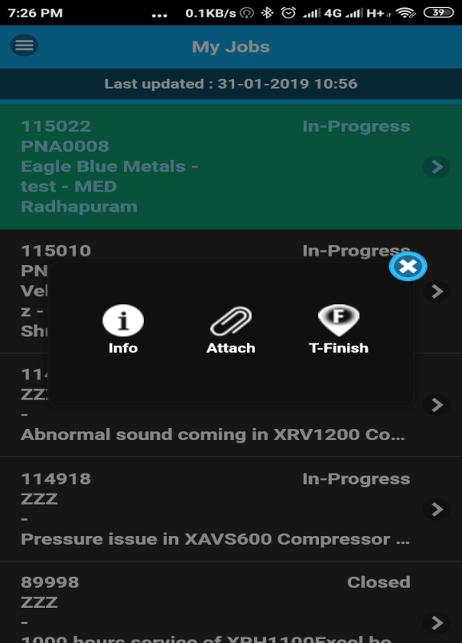

Workstart andWorkfinish:
Now when you are ready to work on machine, press Start button and then press OK:
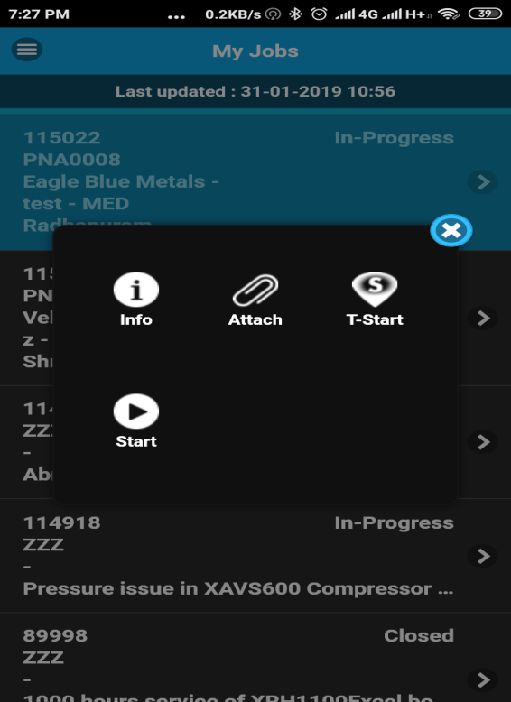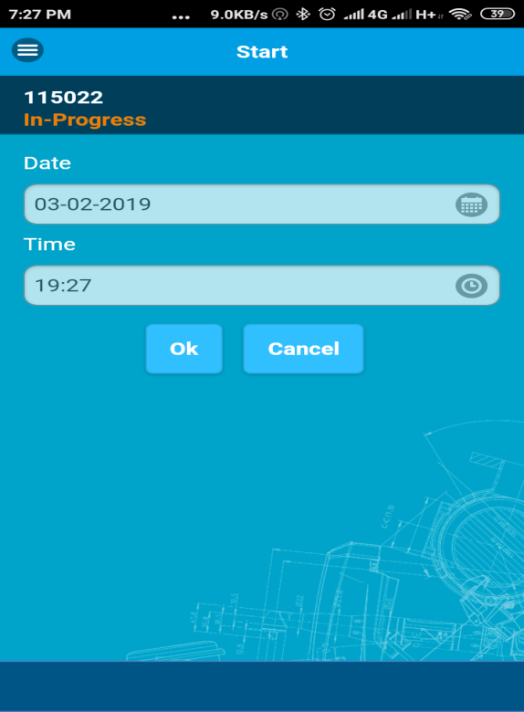

When your work finish for the day, press on Work Finish button and then OK:
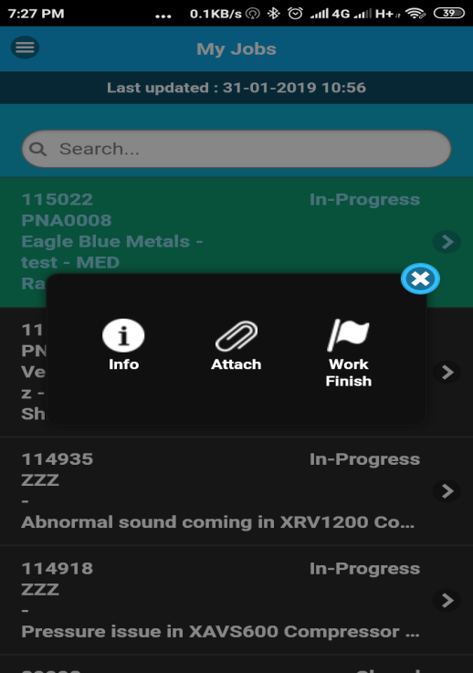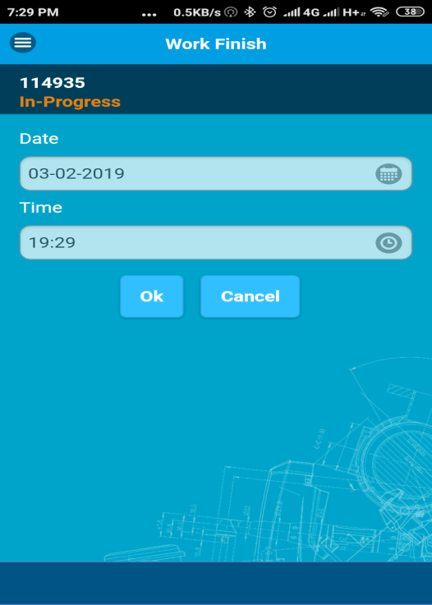

After that choose required LT Commissioning Form as per Machine Model:
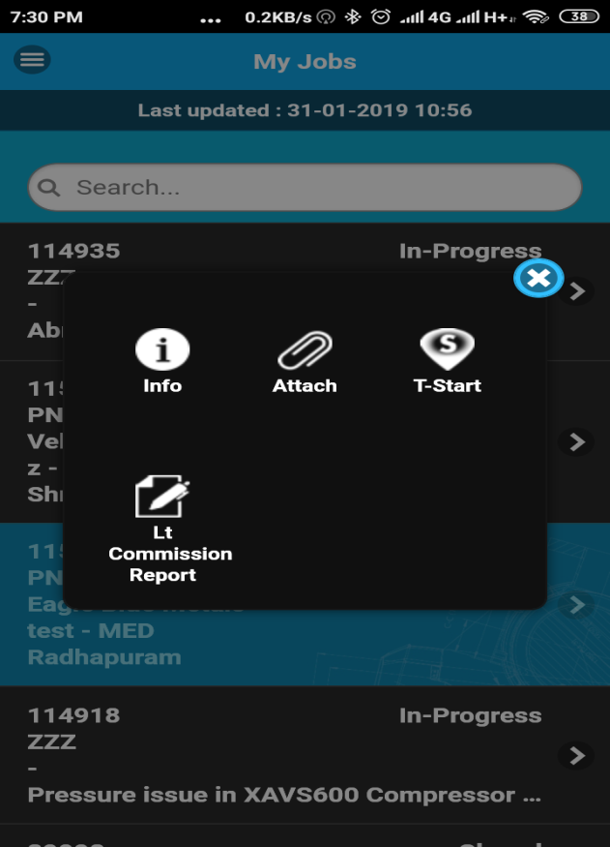

Fill all required fields and press on Preview and check whether report is correct or not:
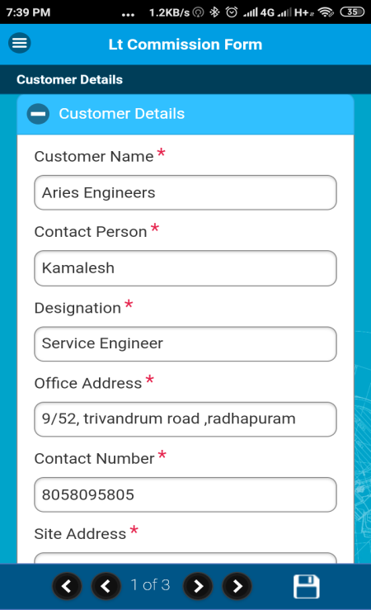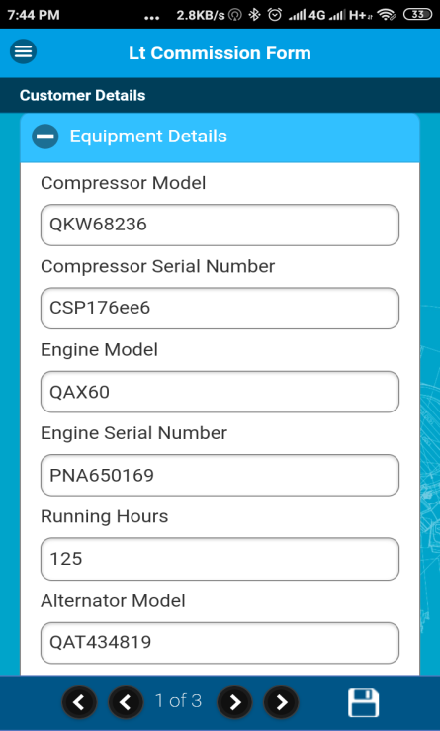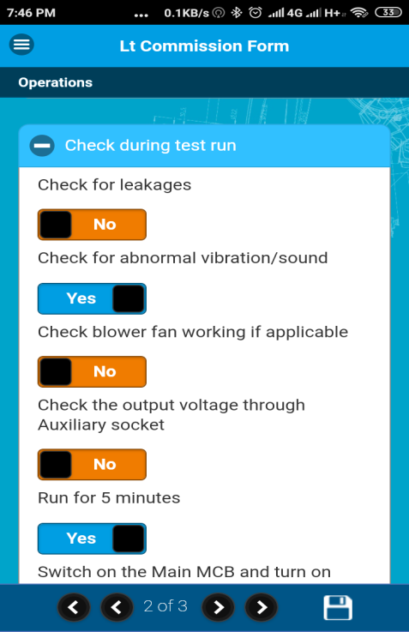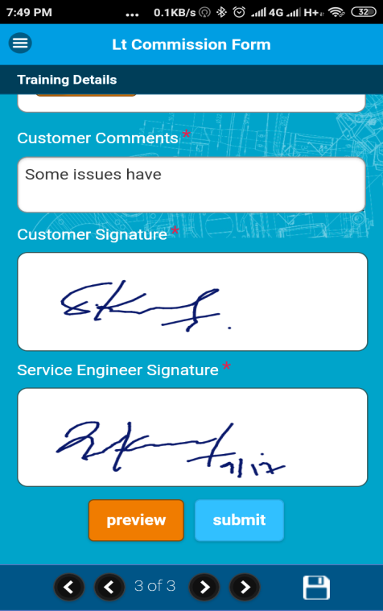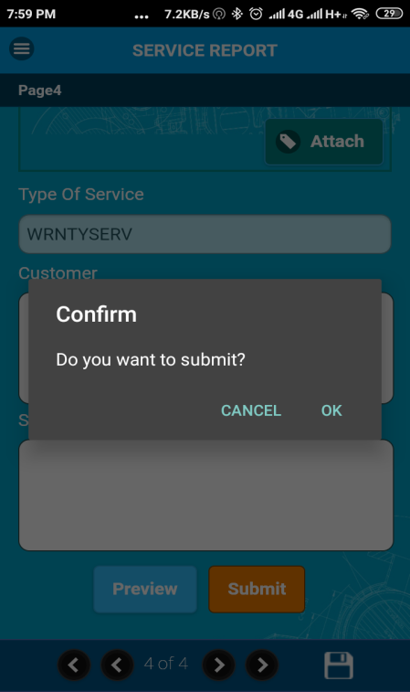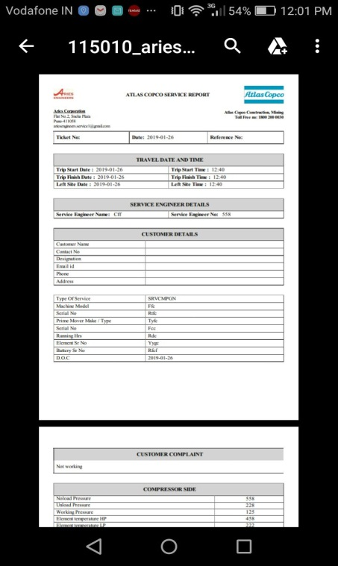

Call finish:
Now press on Call finish option:
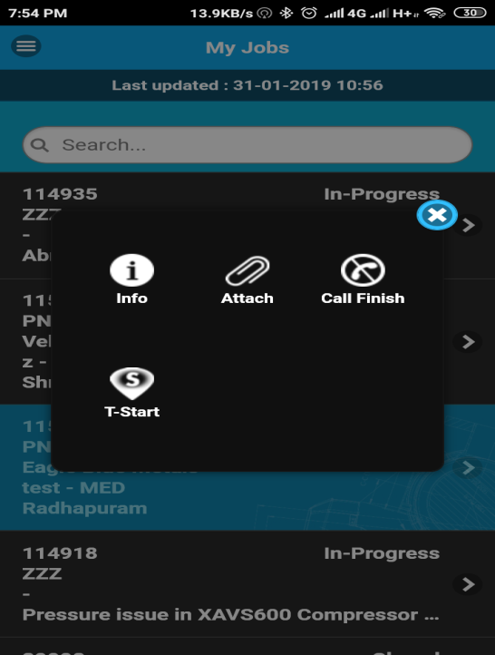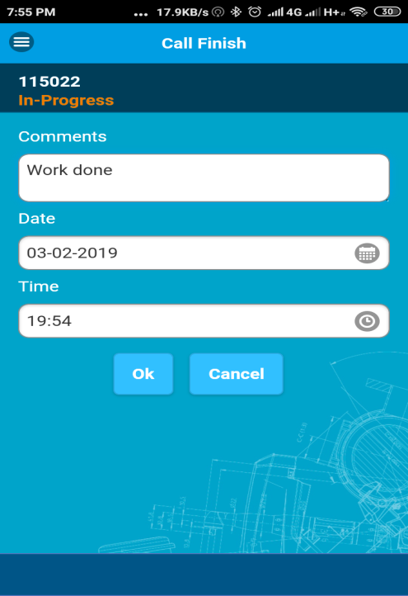
Call has been completed now:
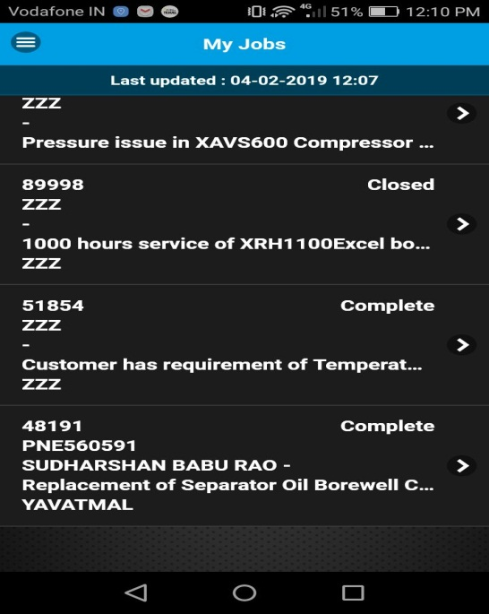

Attachment detail:
You can check your Service Report form by clicking on Attach button:
